**Assignment 1: Add and remove node in DocumentDB cluster and modify the instance type.**

Step 1:

Select the cluster and Go to Actions-> Select add instances.

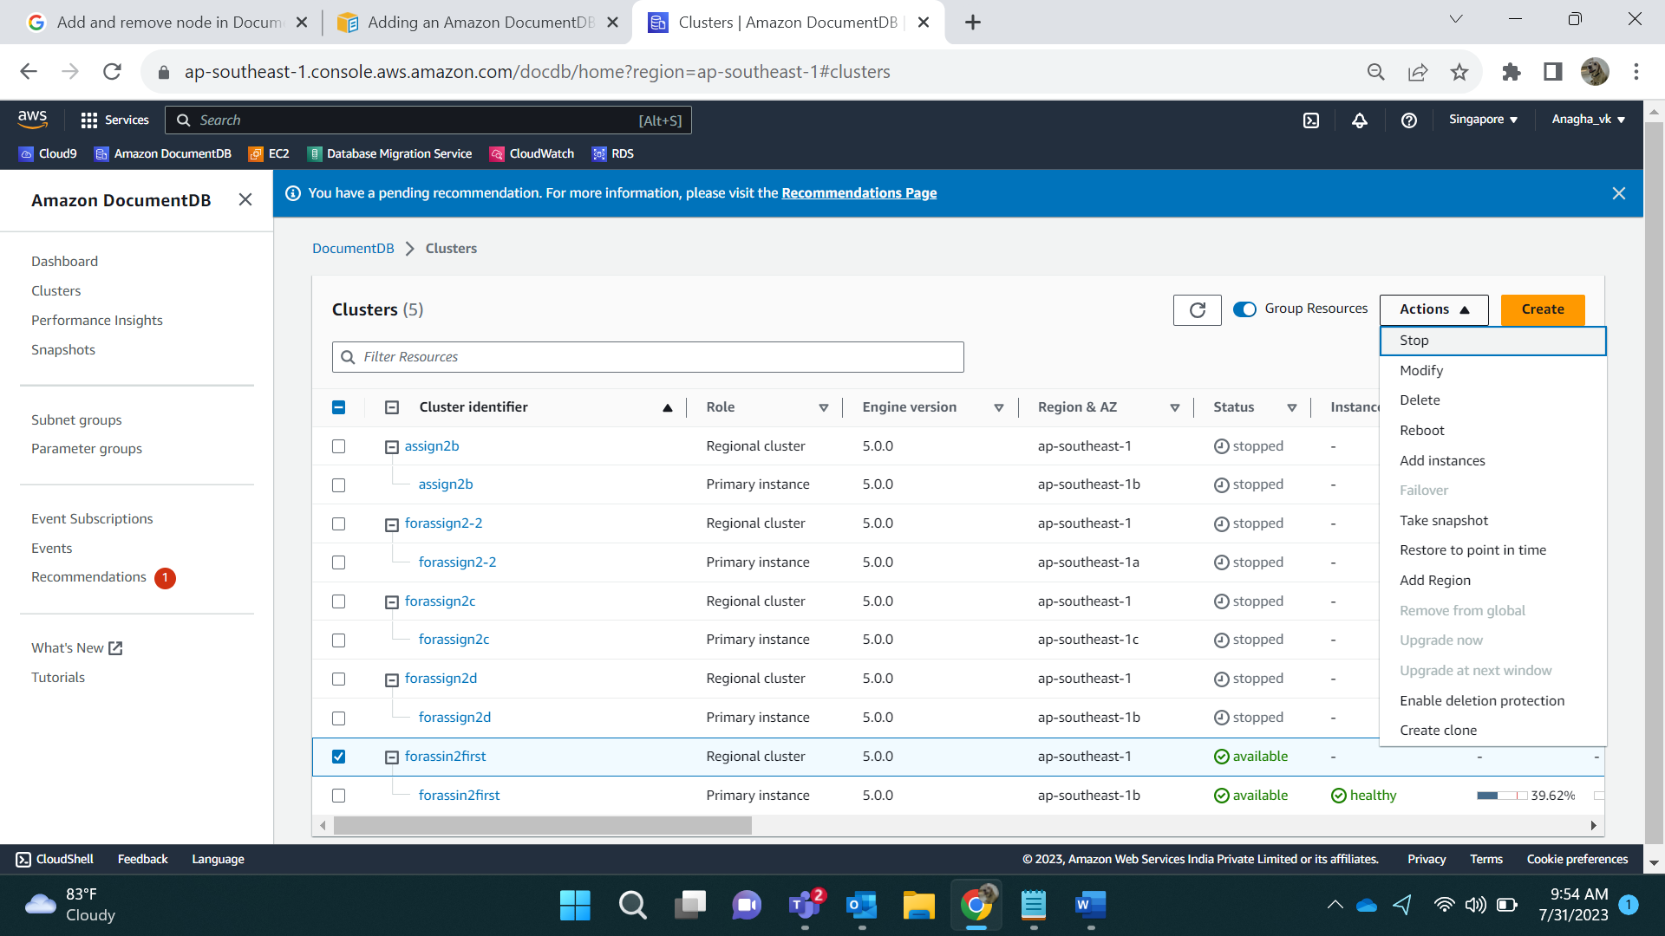

We add 2 instances and click create.

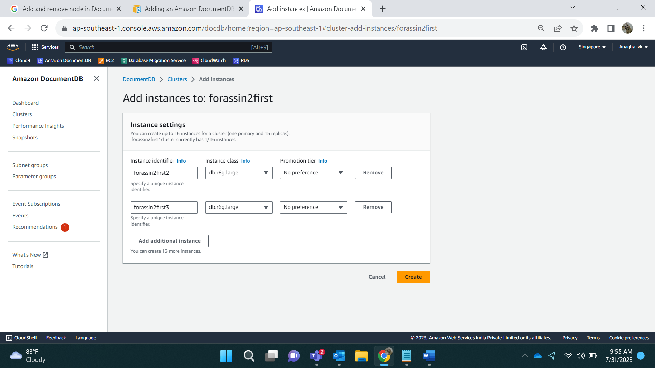

Result:

During creation

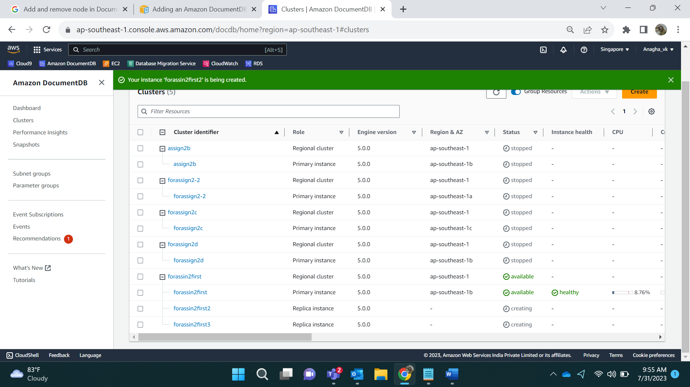

After Creation

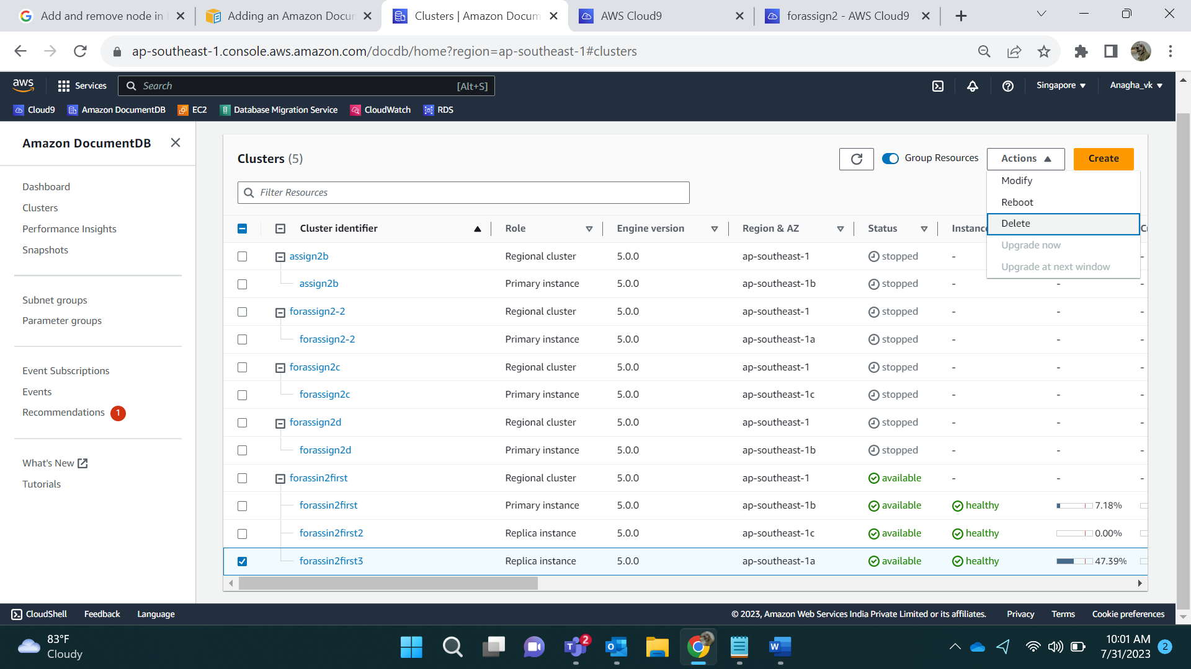

Connect to primary instance:

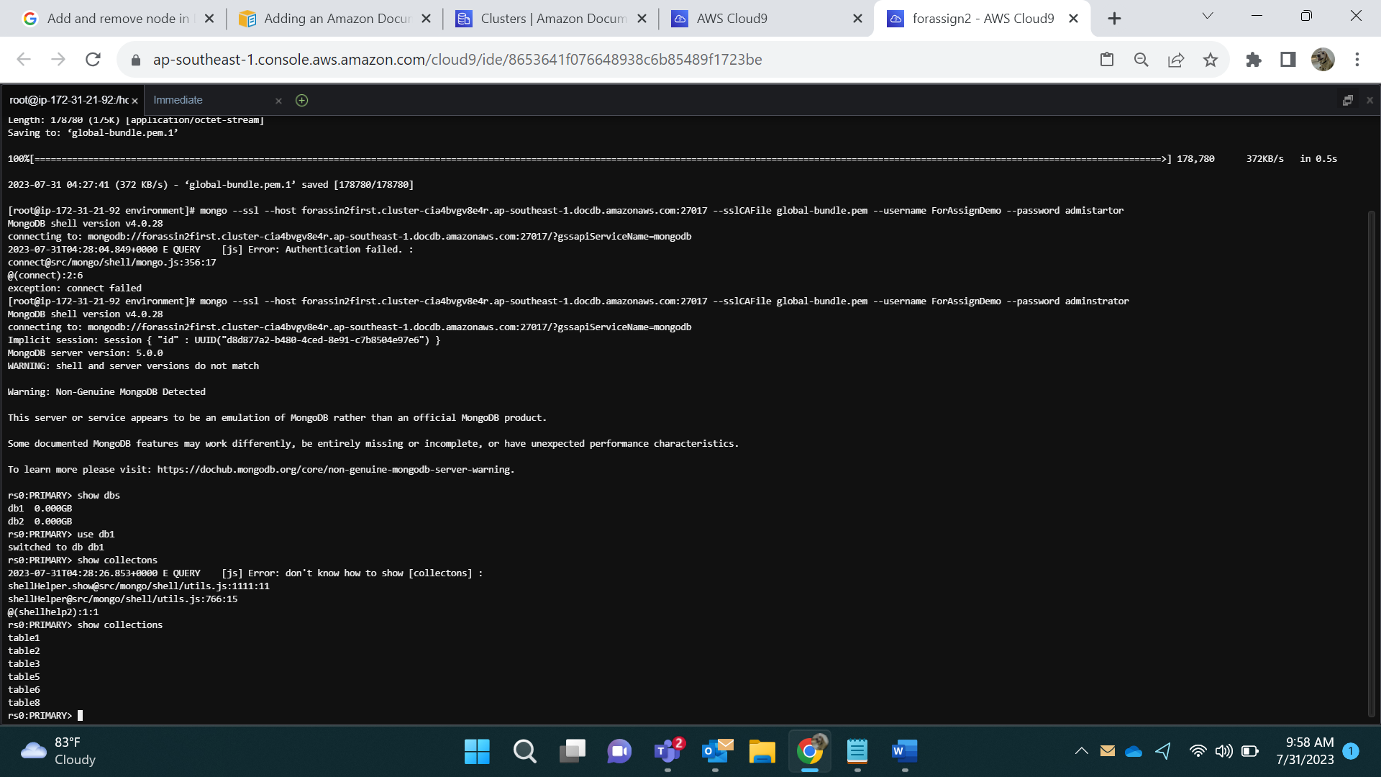

Connect to secondary instance Path:

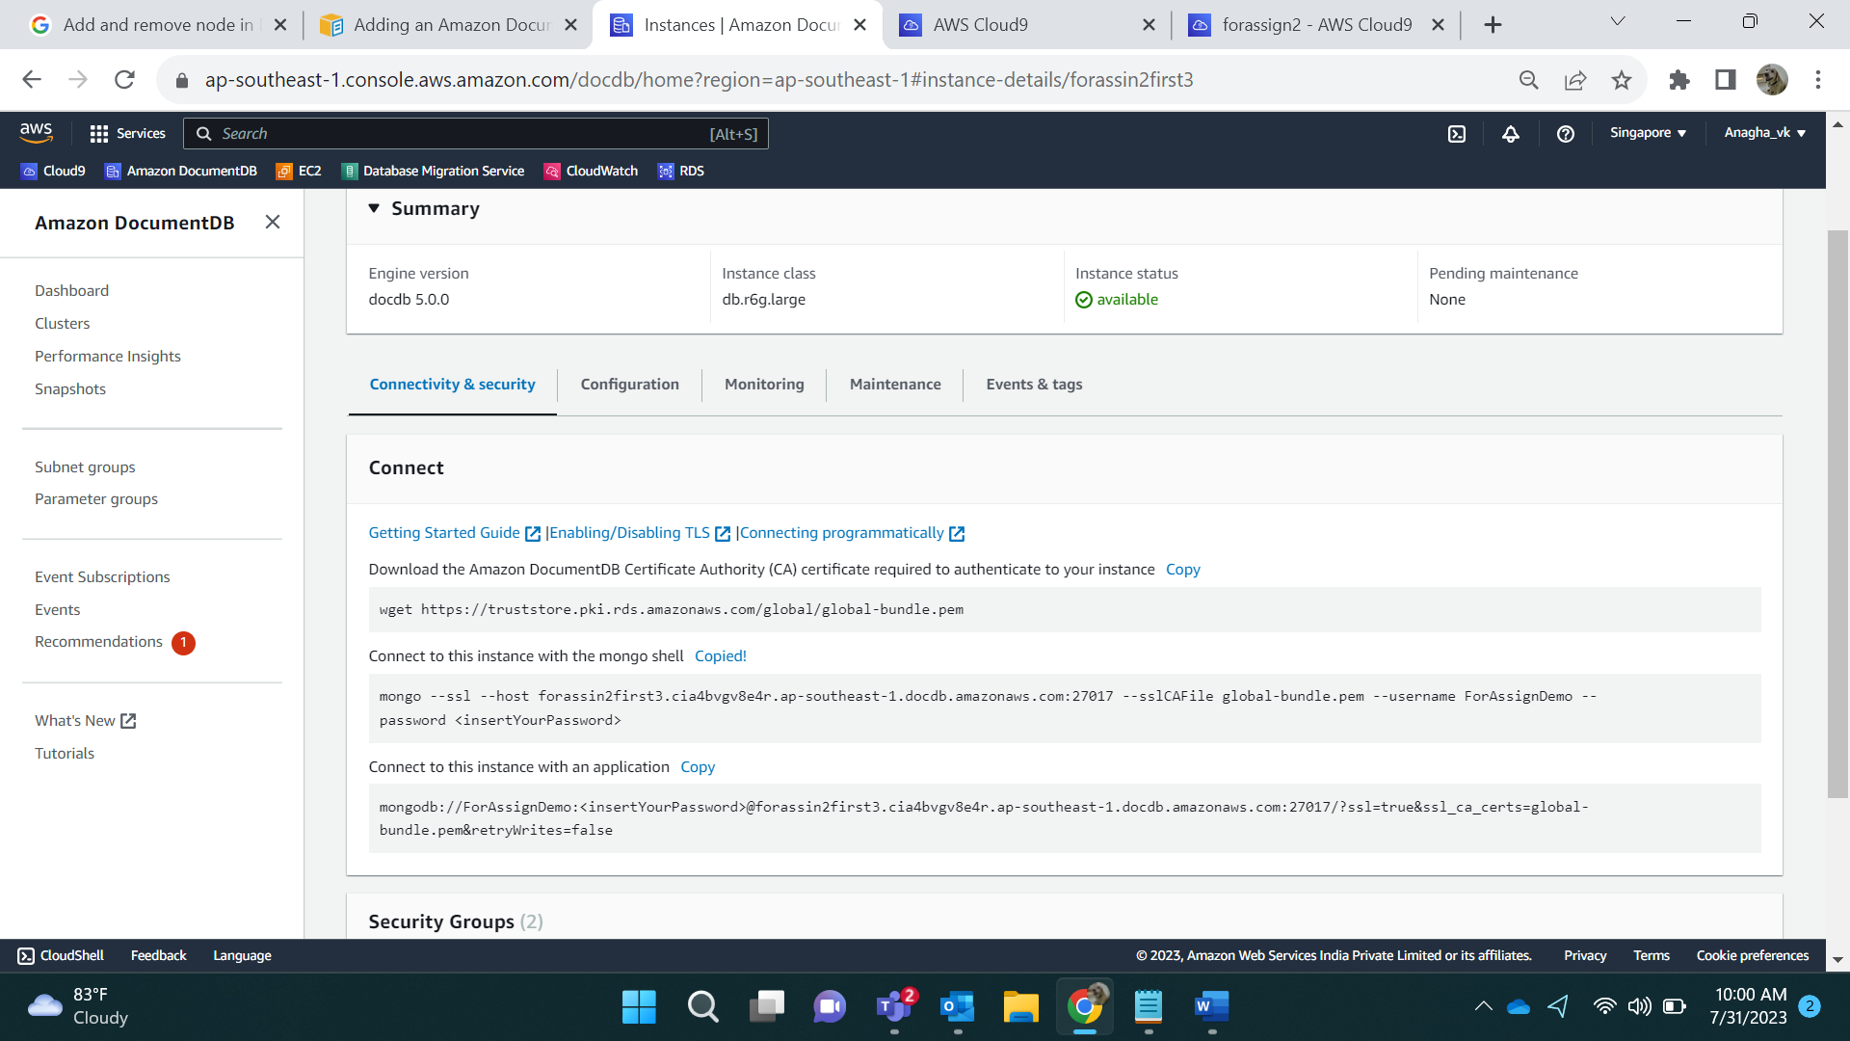

After connection:

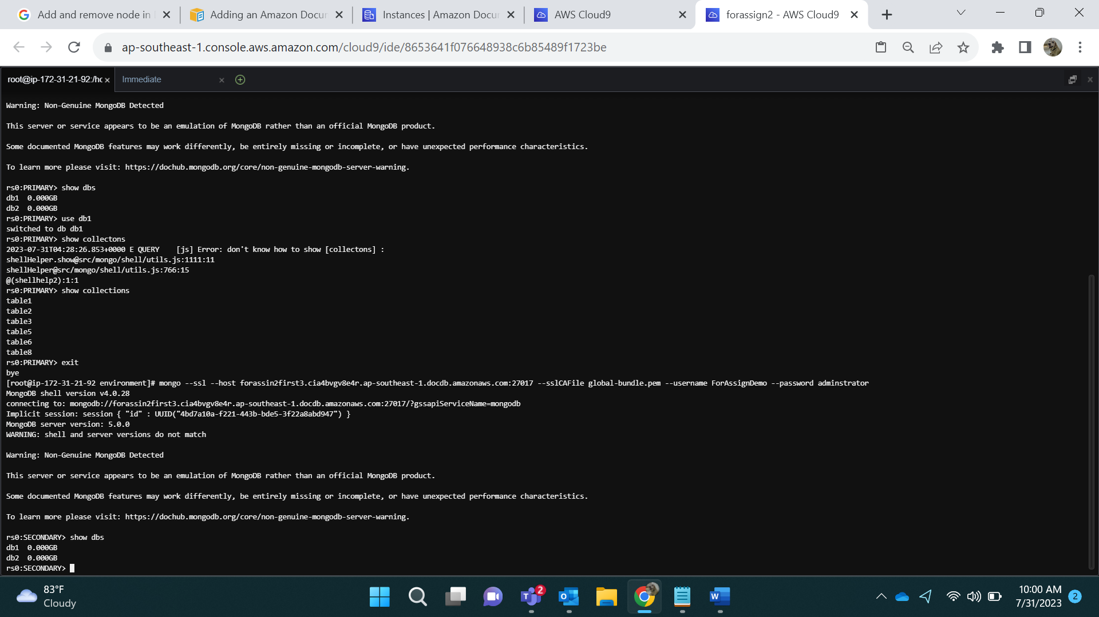

See collections from secondary instances:

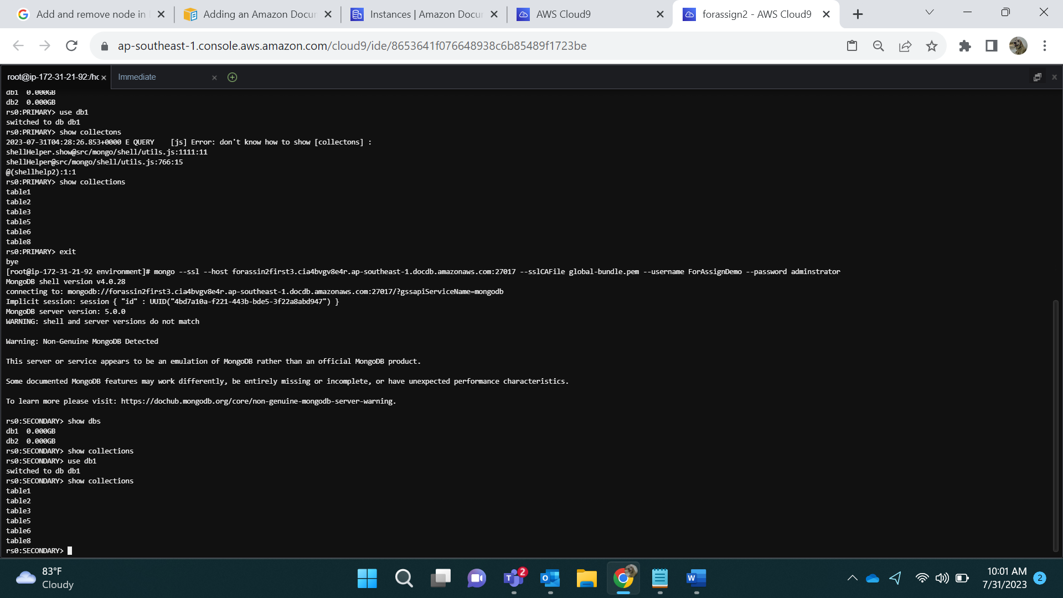

Delete the Instance:

Select the node, Go to Actions-> Delete and conform deletion.



Deleting forassin2first3, asking for confirmation.

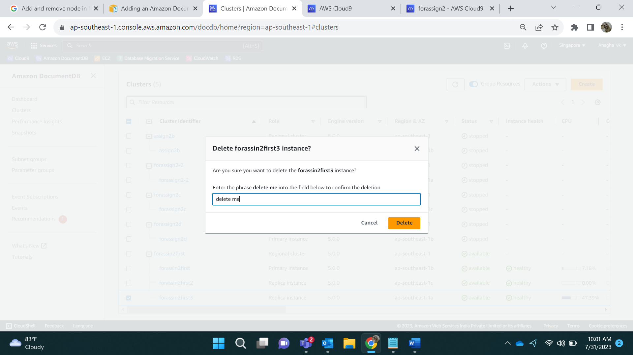

Result:

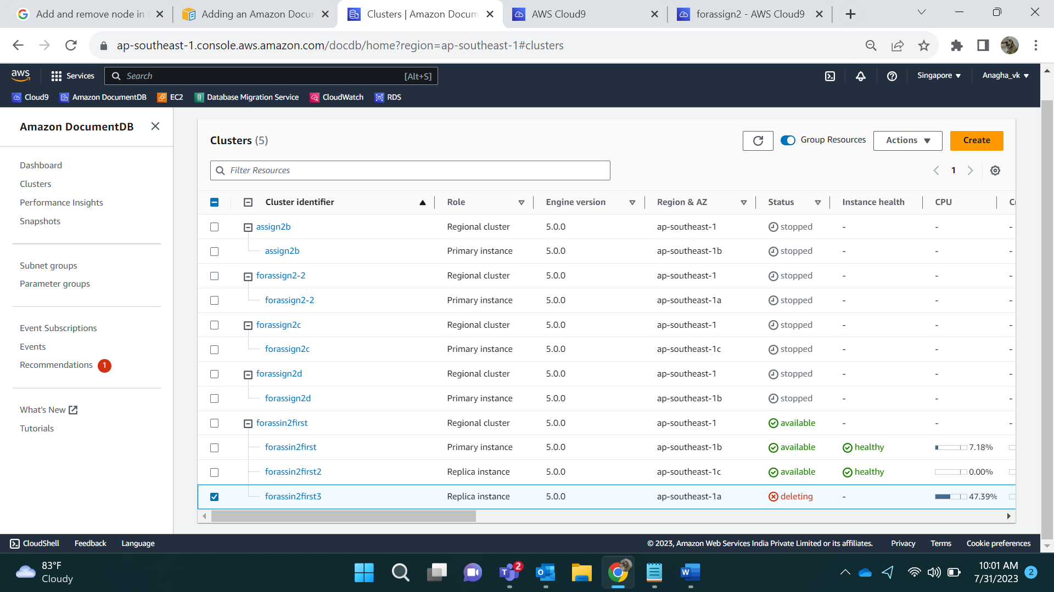

Post Deletion

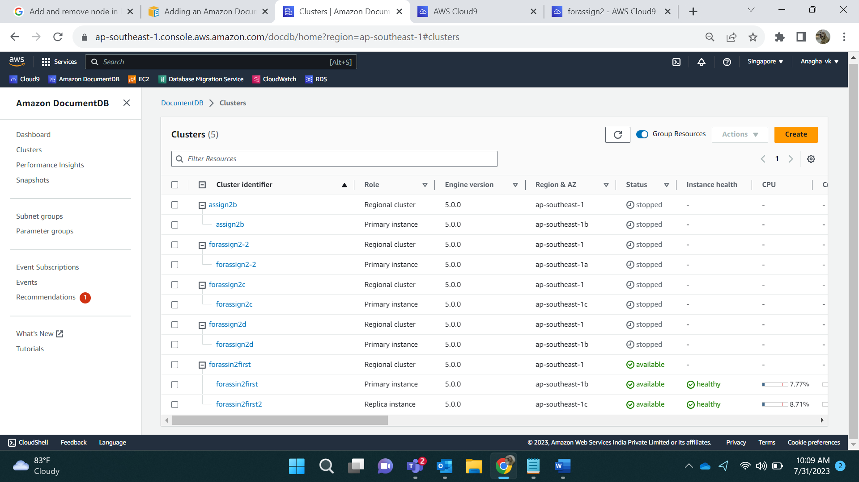

Connecting via secondary instance will not occur since its deleted

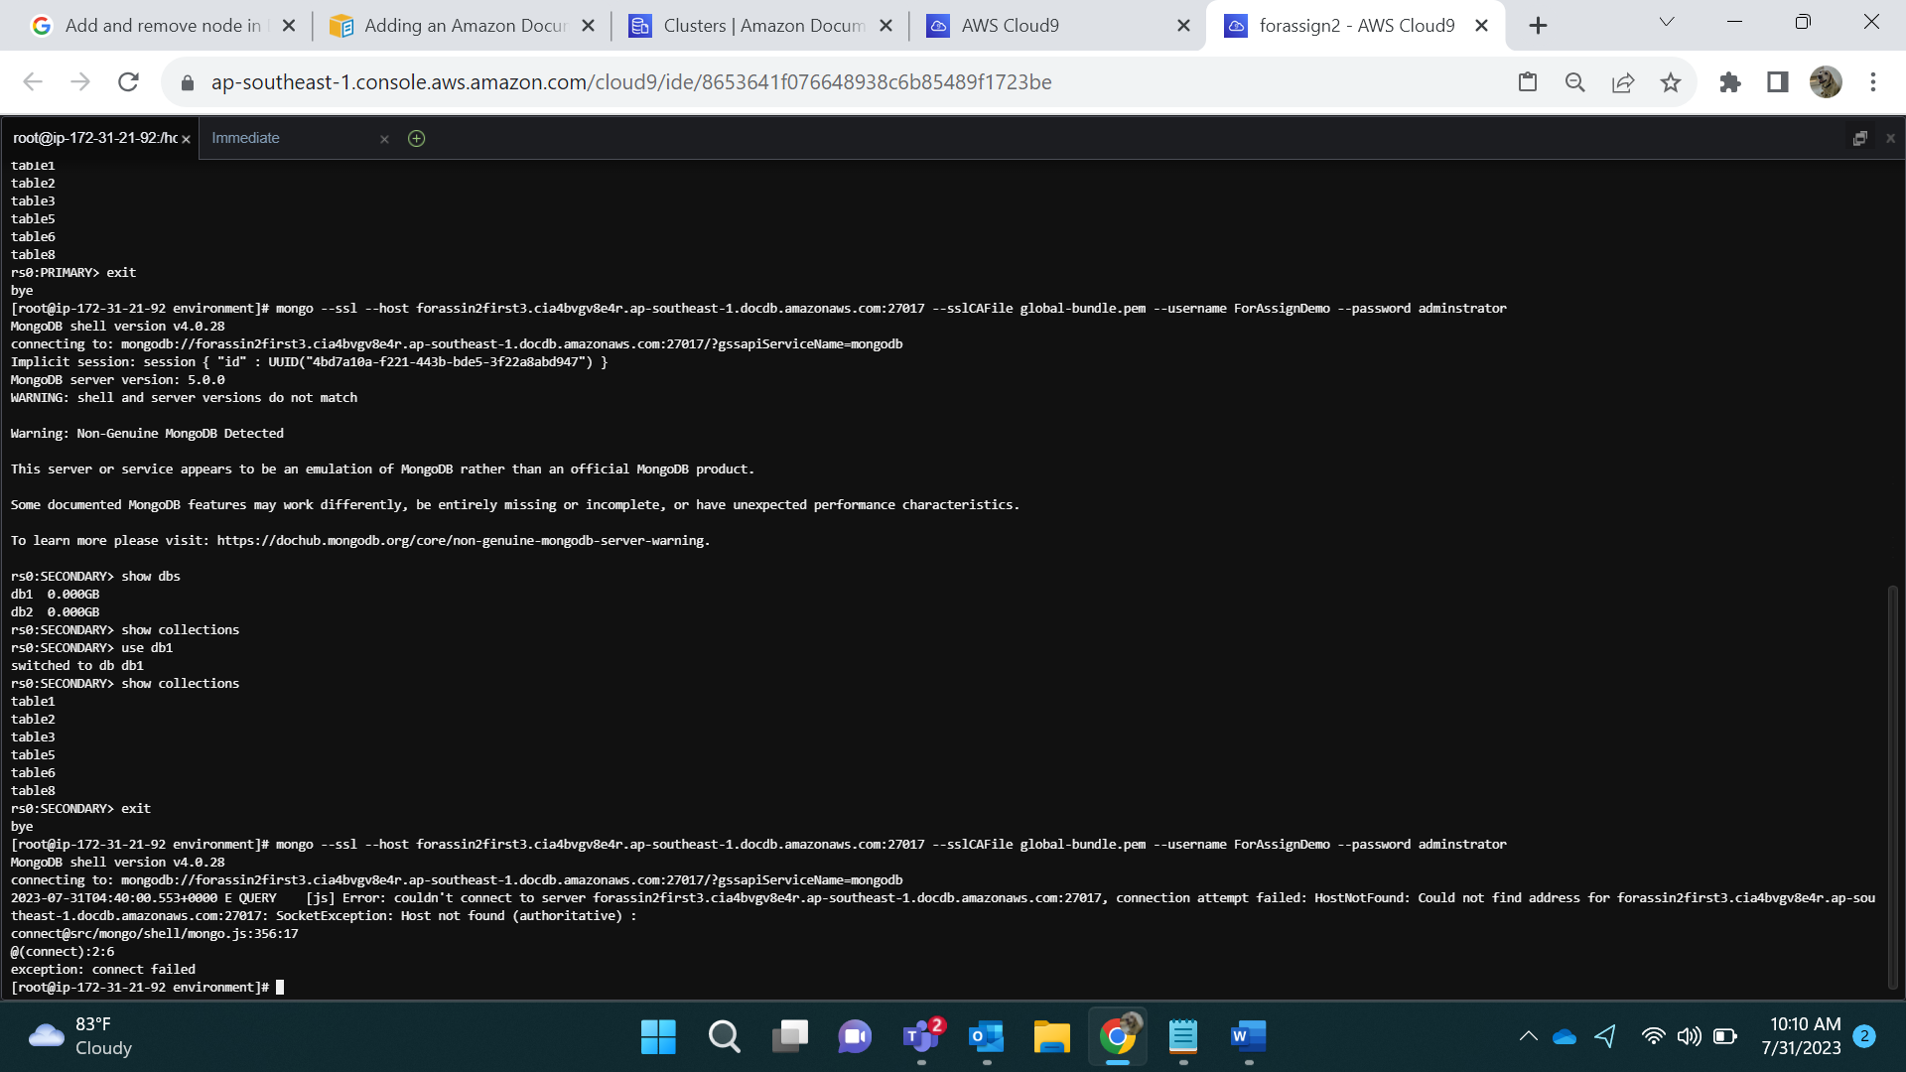

Modify the cluster:

Select the cluster and click on modify:

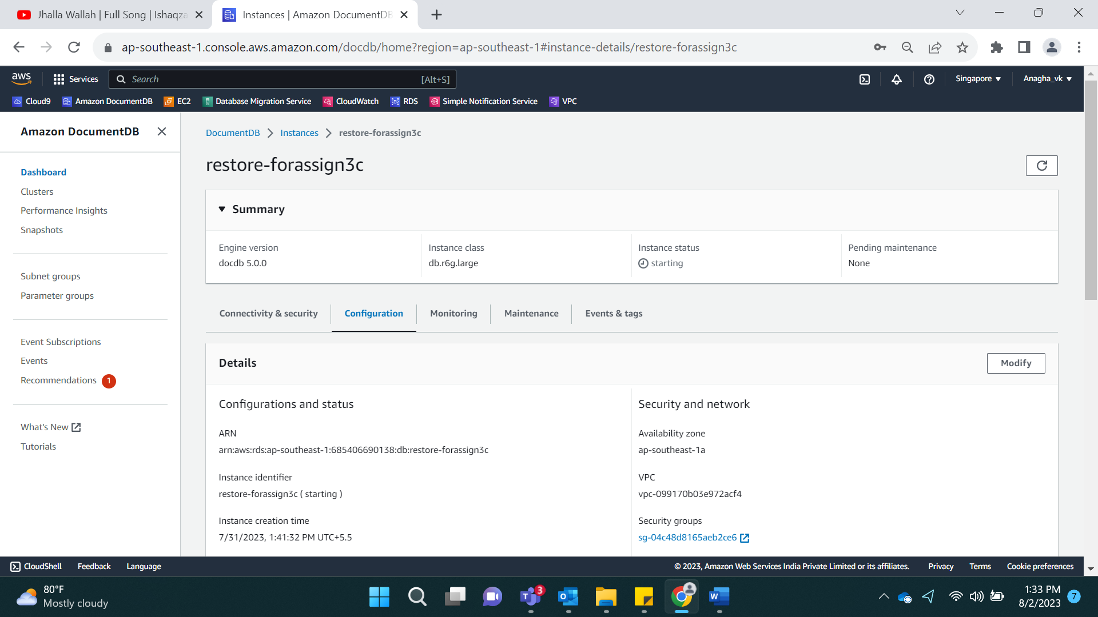

Before Editing:

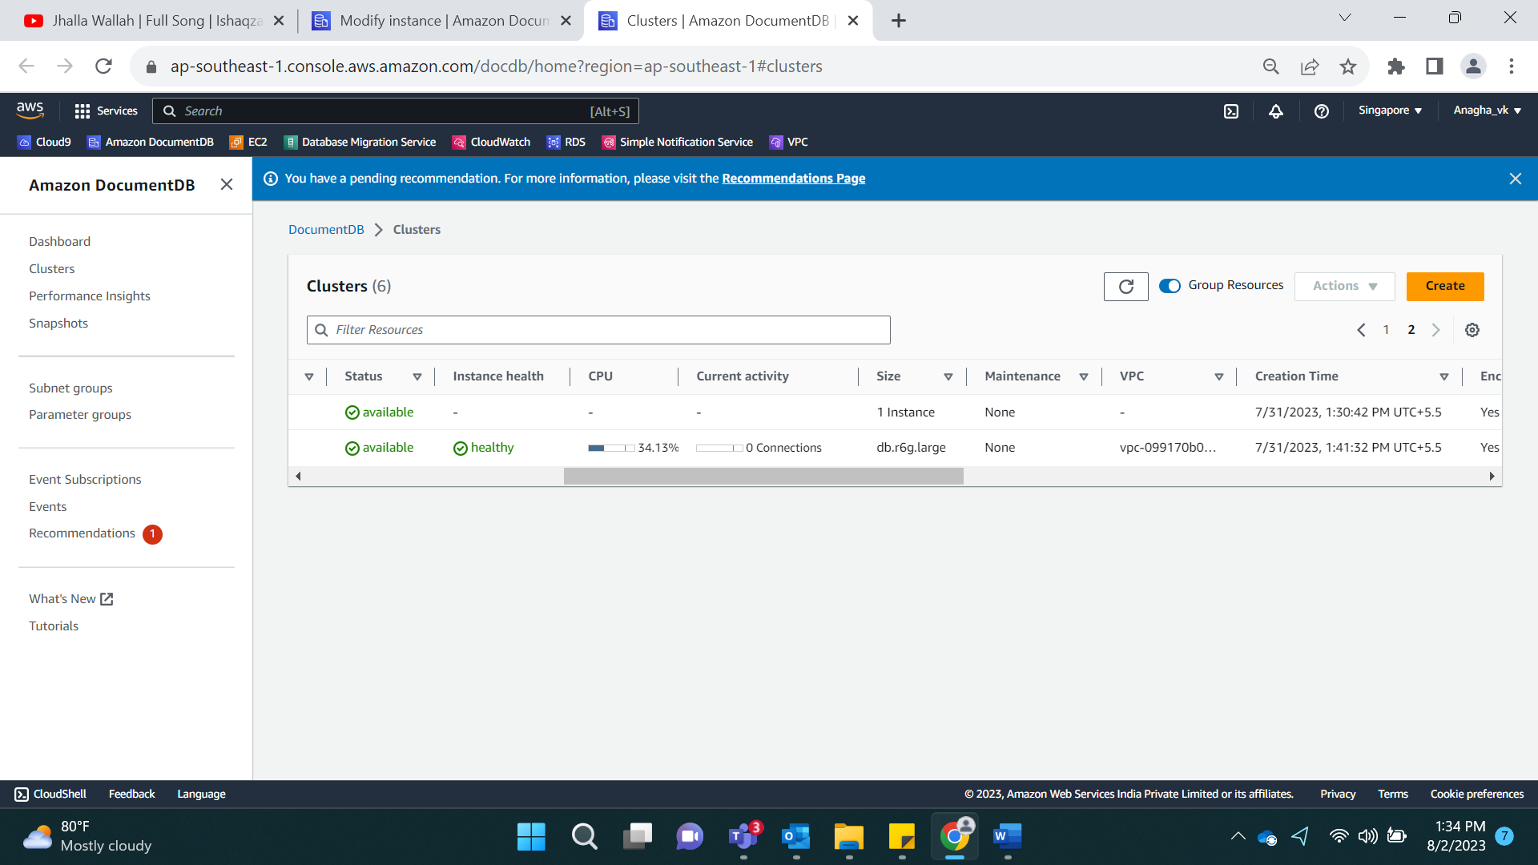

Select the node and modify.

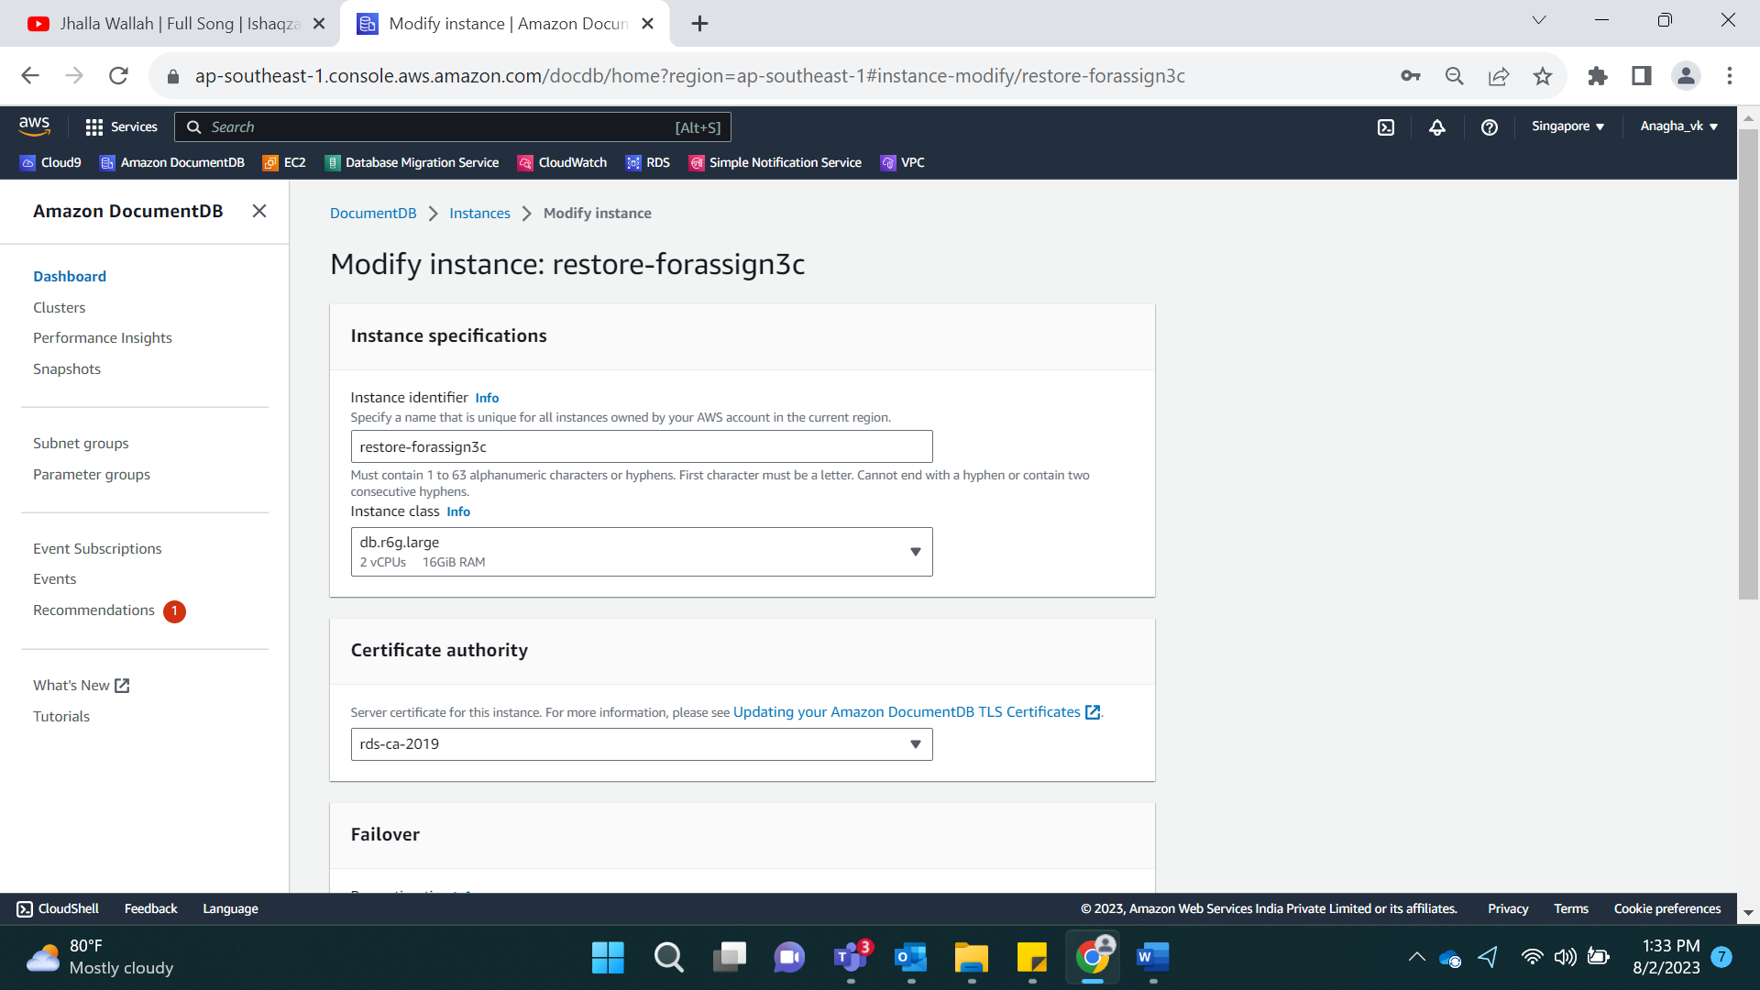

On modification, select db.r6g.xlarge.

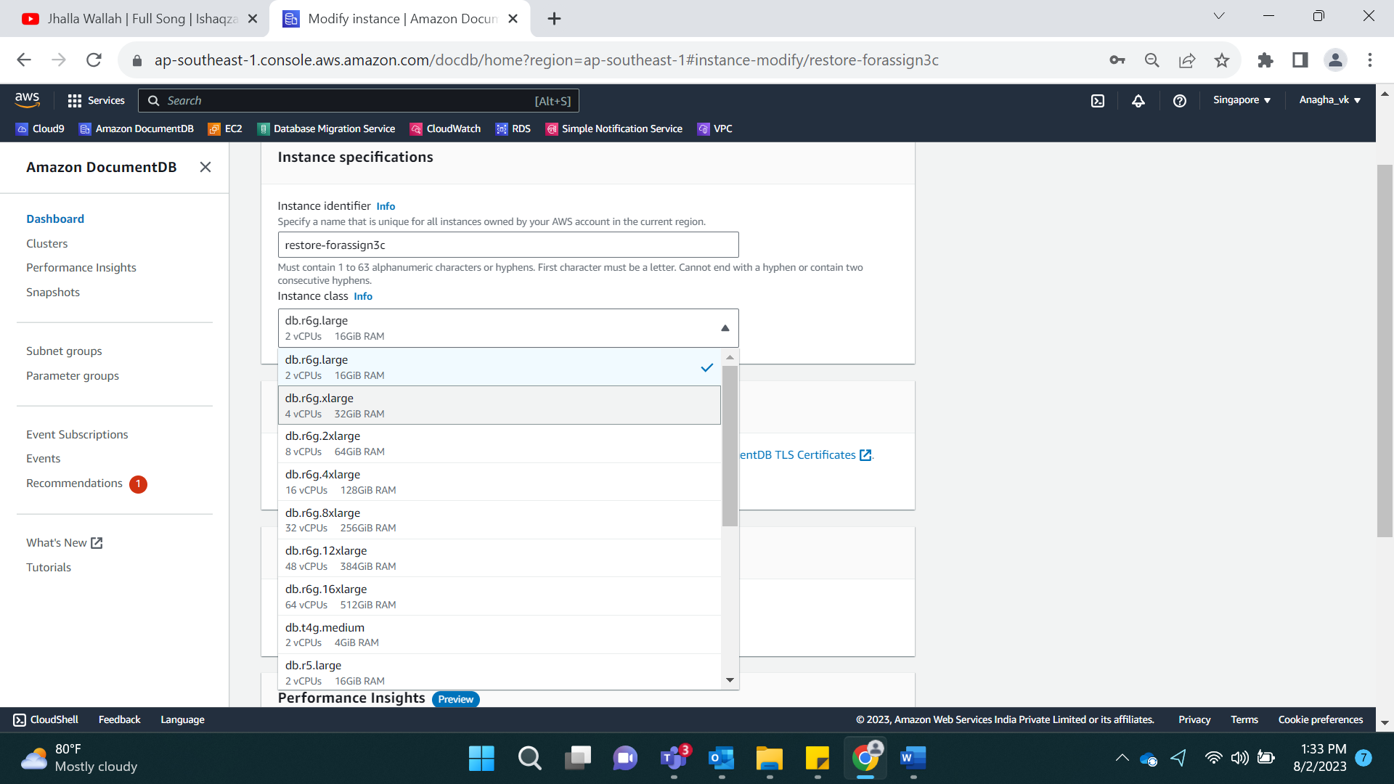

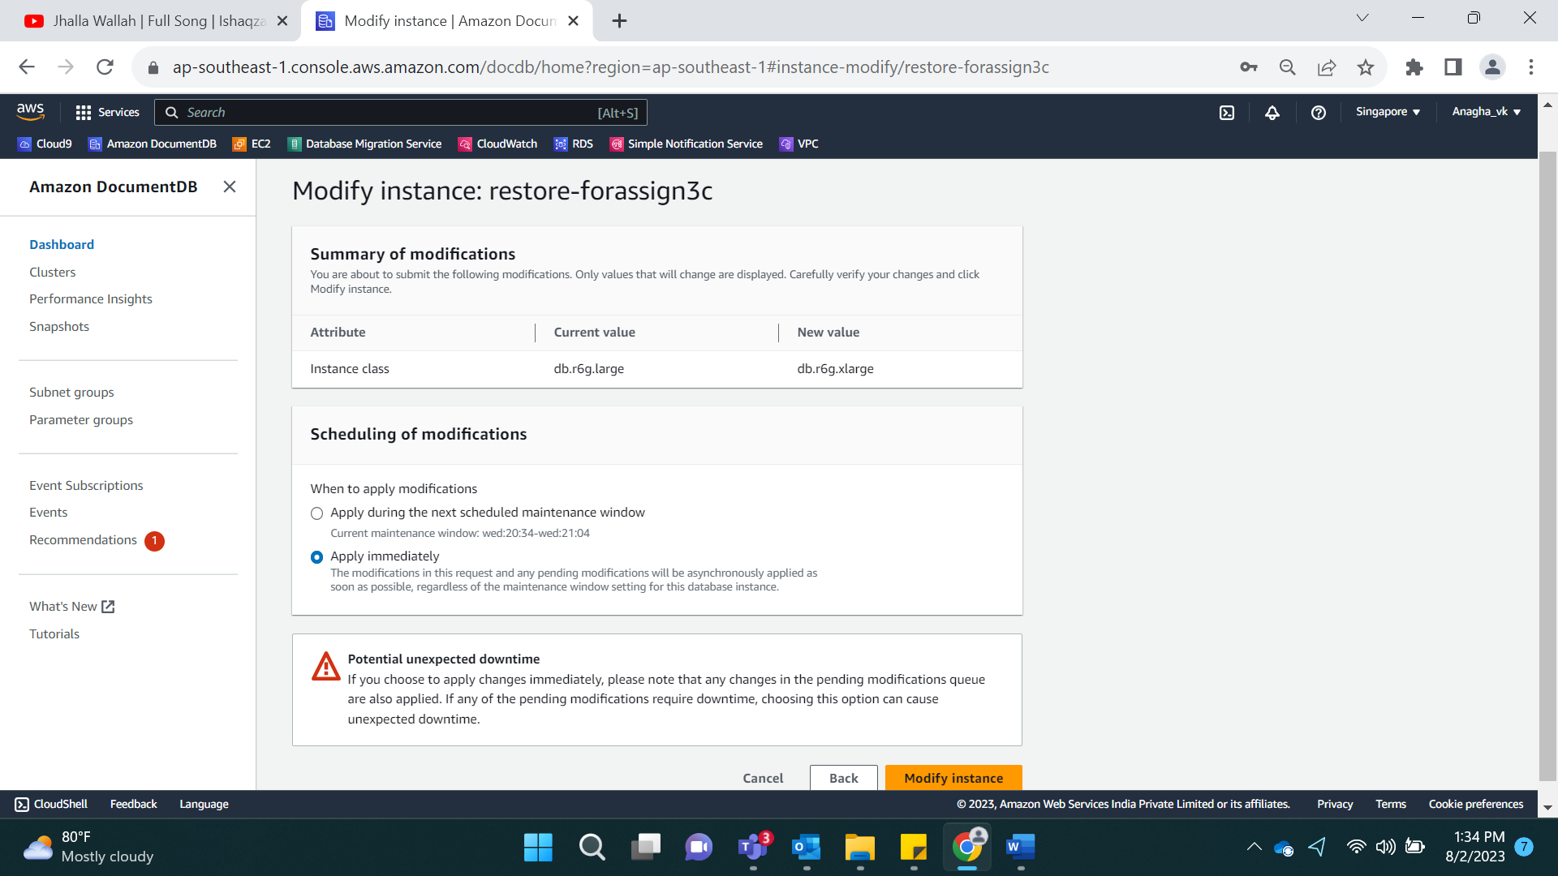

After Edit:

